**Problem Statement**

Goal of this project is to predict if customers of the bank will be exiting in the future or not.

**Architecture**



**Data Details**

1. The data in consideration is a combination of world news and stock price shifts available in Kaggle.
2. [https://www.kaggle.com/shrutimechlearn/churn-modelling](https://www.kaggle.com/aaron7sun/stocknews)
3. There is a total of 13 columns which is a combination of categorical and numerical variables
4. The response label ‘Exited’ indicates if the customer has left the organization or not.

Class 0 🡪 The customer has not chosen to exit.

Class 1 🡪 The customer has chosen to exit.

**Steps Implemented in Model**

**Step 1:** Downloaded the data from Kaggle from the link given above.

**Step 2:** Performed feature engineering which includes

* Removing outliers
* One hot encoding

**Step 3:** Split the predictors and response and scale the data.

**Step 4:** Clustered the data based on the ‘balance’ column.

**Step 5:** Performed train test split.

**Step 6:** Created a Artificial Neural Network Model

**Files to run the model**

1. Churn Modeling.ipynb
2. Churn_Modelling.csv

**Observation**

**For datasets with balance = 0**

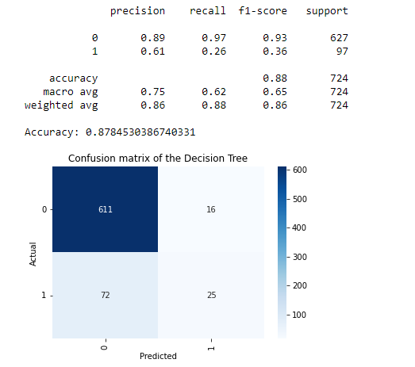

**For datasets with balance != 0**

